**ST.THERESA’S ARTS AND SCIENCE COLLEGE FOR WOMEN,**

**THARANGAMBADI - 609313**

**DEPARTMENT OF PHYSICS**

Charting the Course of Innovation: A Startup Analysis

BY

**TEAM LEADER**

K.NANDHINI

**TEAM MEMBERS**

R.HARIDEVI

G.KAVIYAZHINI

S.SHARMILA

CHARTING THE COURSE OF

INNOVATION: A STARTUP ANALYSIS

## INTRODUCTION

Starting a new company can be an exciting and rewarding experience, but it also requires careful planning and analysis to ensure that the business is viable and successful. There are several key areas that you should focus on when conducting a startup company analysis. Conducting a thorough analysis of these areas can help you identify potential challenges and opportunities, and develop strategies to address them. It is also important to regularly review and update your analysis as the business progresses, in order to adapt to changing market conditions.

## OVERVIEW

The term startup refers to a company in the first stages of operations.

Startups are founded by one or more entrepreneurs who want to develop a product or service for which they believe there is demand. These companies generally start with high costs and limited revenue, which is why they look for capital from a variety of sources such as [venture capitalists](https://www.investopedia.com/terms/v/venturecapitalist.asp).

In their newness, startups usually focus on raising capital to further product development. Raising such funds is always a long and tedious, and a startup needs to make a strong argument that supports the viability of its business idea. Some renowned startup companies include Air bob, SpaceX, Avant, and Pinterest.

## PURPOSES

**The purpose of a startup:**

The purpose of a startup is multi-faceted, depending on the individual or team behind the venture. Generally, though, the purpose of a startup is to create something new and innovative. A startup is often the first step in launching a business venture, and is the beginning of an entrepreneurial journey.

Ultimately, the purpose of a startup is to fulfill an ambition or goalto bring an idea to life and turn it into something tangible and meaningful. Whether it’s making money, having an impact on society, or simply following ones passion, startups provide individuals with the opportunity to pursue their dreams and create something extraordinary.

**The Purpose of a Startup to Be Valuable**

The purpose of a startup is to create value. That value can come in many forms, from financial return to improved quality of life to solving a major problem. But no matter what form it takes, startups are designed to bring something new and valuable into the world.

Creating value also means creating something that people can use in their everyday lives. This means that a startup has to have a sound business model, which includes generating enough revenue to cover costs and creating a steady stream of income. A successful startup needs to develop innovative ways to monetize its product or service.

**The Purpose of a Startup To Make Something People Want:**

The purpose of a startup is to create something that people want. This could be anything from a product or service, to a new type of technology or business model. Startups are often the first to bring innovative ideas to market and play an important role in driving economic growth and creating jobs.

The ultimate goal of startup customers by providing a product or service that meets their needs. This requires a deep understanding of the target market and the ability to develop a solution that meets those needs. Startups must be able to quickly identify and respond to customer needs and trends in order to stay ahead of the competition.

# PROBLEM DEFINITION AND DESIGN THINKING

According to the Startup Genome Report, 74% of internet startups fail due to premature scaling. Of these, 60% were focusing on. As a startup, one of the most important things you can do is financial analysis. This will give you a clear understanding of your business’s financial health and where you need to make improvements. They are a few key financial metrics that you should focus on when doing your analysis. The first is your gross margin. This is the difference

between your revenue and the cost of goods sold. A high gross margin means that you are making a lot of money on each sale. The second metric is you’re operating expenses. This includes all the costs associated with running your business, such as rent, salaries, and marketing. A low operating expense ratio means that you are not spending too much to run your business.

Starting the product during their initial lifecycle phase, whilst 80% of those startups that scaled successfully were focusing on discovering a problem. In other words, finding and defining a real problem is critical to startup success. The creation of value starts with the problem that is being solved: a problem dictates a need, and the fulfilment of that need is the value that is created for the customer. Successful startups succeed because they find a real and meaningful problem to solve for a (large enough) group of customers; whereas failed startups effectively.

# DESIGN THINKING:

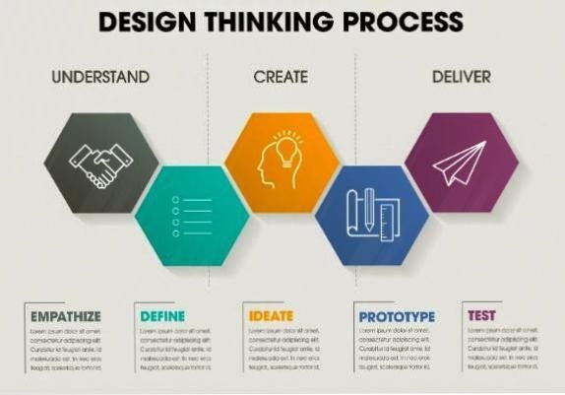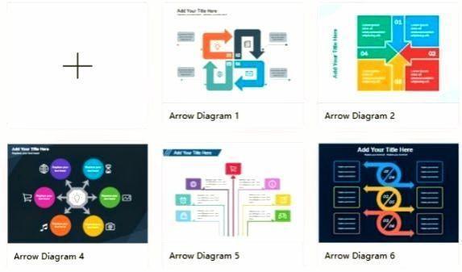

* 1. **EMPATHY MAP**

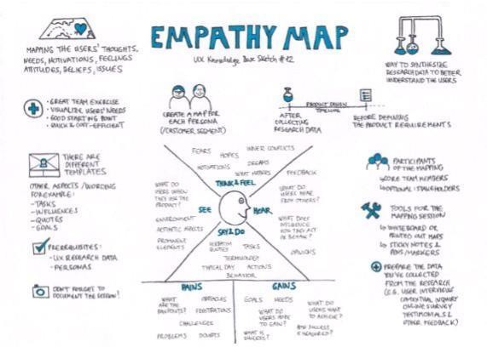



* 1. **BRAINSTORMING MAP**

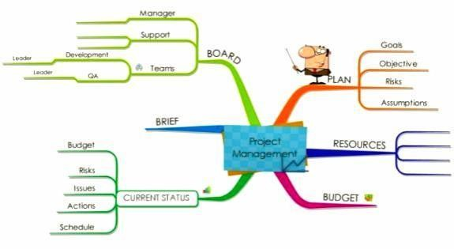



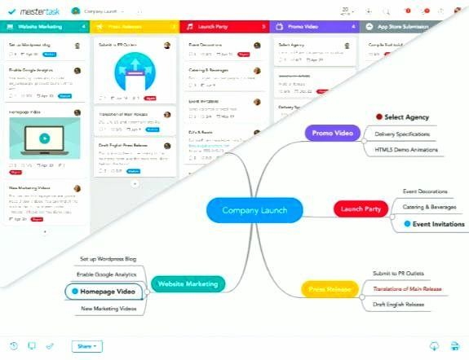

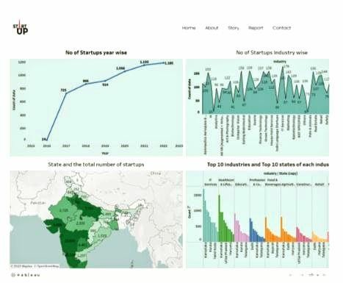

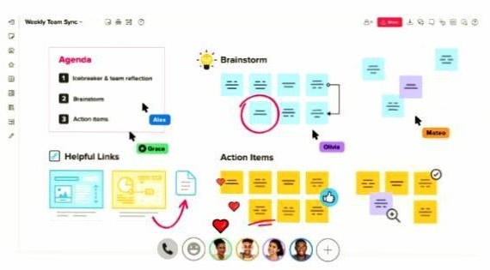

# RESULT

#### OUTPUT OF THE RESULT

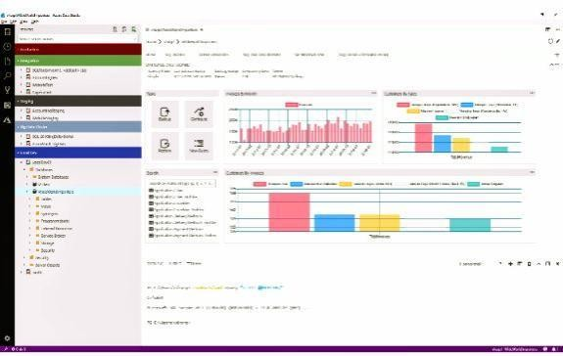



# APPLICATION

Startup is described by a large volume of data, both structured and unstructured data. Much of the value of this large company comes from data that is continuously analyzed with the aim of being able to offer better service to serve its customers. The analysis carried out also aims to develop products and produce new features.

Without proper analysis, what is produced and issued by this company cannot be on target. Big Data technology is currently widely used in startup or startup companies. The application of Big Data in this startup company provides many benefits and advantages for the startup company itself. The following is an example of implementing Big Data in a Startup business that is important for you to pay attention to:

### Lots of Data Personalization:

The first example of implementing Big Data at startup is personalizing a lot of data. If the previous technology made personalization of data difficult and long to do with Big Data technology, it all feels easier.

The purpose of personalizing this data is to improve and improve user satisfaction from the startup business. With this application, businesses can take advantage of data and then present various kinds of attractive offers because the needs of users can be clearly read.

The next application is tracking and also customer habits. With this implementation the company can easily offer something because it relates to what is needed by the user. For example, a travel startup, by implementing Big Data, it can directly target customers with the same criteria. Travel startups are able to offer hotels, tickets as well as tours to the right customers.

**Application in Online Transportation Startup:**

The examples of implementing Big Data for each startup company are different. Therefore, the solutions provided by Big Data can also be different in terms of the type of business, consumers and the area where the business is established. Many startups whose focus is on online transportation are using this Big Data technology. With Big Data startups are easy to get data from consumers. With this data, it can be used to improve services and also make innovations in services.

The application of Big Data at startups makes these startups able to know the activities and know the trends that are mostly carried out by customers. With this they will be able to provide the right recommendations for their customers such as free shipping, vouchers and discounted prices and so on.

The way Big Data analyzes customer activity is after making a transaction. Looking at the transaction history carried out by this technology, it will provide recommendations that startups can do where this is still related to the transaction history. They do this innovation to satisfy customers and can only be done if the company implements Big Data in their company.

With our Big Data solutions, your company can make decisions more quickly, precisely and accurately. Even your business will be more confident thanks to the right and fast analytics from Big Data.

# ADVANTAGE & DISADVANTAGES

## ADVANTAGES:

For startups, financial analysis is essential to understand where the business is today and where it needs to be in the future. [Financial](https://fastercapital.com/content/Get-Financial-Analysis-for-Your-Startup.html#The-Benefits-of-Financial-Analysis-for-Startups) [analysis can help startups](https://fastercapital.com/content/Get-Financial-Analysis-for-Your-Startup.html#The-Benefits-of-Financial-Analysis-for-Startups) in a number of ways, including:

1. Determining whether the business is on track to meet its financial goals.
2. Identifying areas of the business that are overspending or underperforming.
3. Benchmarking the business against similar companies in the industry.
4. Providing insights into the company's overall financial health.
5. Helping to raise capital by providing potential investors with a detailed understanding of the company's financials.
6. Facilitating better decision-making by managers and owners.
7. Enable a company to track its progress over time and make necessary adjustments along the way.
8. Help identify potential problems early on so that they can be addressed before they become too costly.
9. Assist in the development of long-term financial plans.
10. Enable a business to better understand its customers, competitors, and industry as a whole.

Financial analysis is an important tool for all businesses, but it is especially critical for startups. By taking advantage of all that financial analysis has to offer, startups can set themselves up for success in the long run.

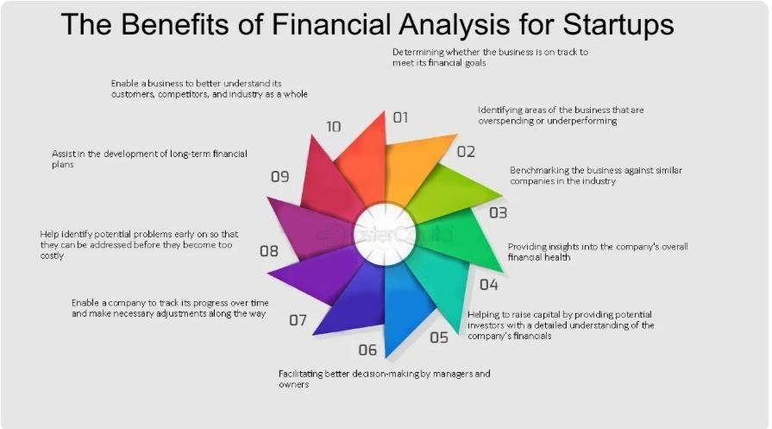

## DISADVANTAGES:

**Risk**

Most startups fail within their first year of operations, so the risk of failure is high. Working under such high risk can blur a startup’s strategic vision. So they either fail to seize market opportunities or overestimate their sales projections. High risk also hinders a startup’s ability to attract experienced and competent staff.

**Compensation**

It takes blood, sweat, and tears to build a company, and long working hours are the norm for startups. The rewards might be low since it takes time to generate revenue and make profits. Some startups give up since it’s demotivating to work without proper compensation.

**Market Access**

Many customers prefer a business that they have worked with over a new startup. Besides it is more expensive to acquire new customers than to retain old ones.

Without a customer base, understanding market needs also becomes a real struggle. All these factors combined increase the cost of business development for startups.

**Team Composition**

Some startups are born out of desperation since the founder could not find or hold on to a job. Such founders often struggle to build a team that the business needs to succeed. A successful startup requires founders/co-directors with complementary personalities and competencies. Even then disagreements can creep in when the going gets tough.

**Resources**

Growth hacking, cloud computing, and venture capitalism allow startups to gain market entry. Most startups operate on a shoestring budget, against competitors that are well-resourced. It gives the competitors an edge in product development, sales, and marketing. They use that edge to push startups out of the market when they become a threat.

**Processes**

Startups are flat organizations that lack defined business processes and operational procedures. This exposes them to poor customer service, legal liability, and financial losses. Startups might thus opt to out source non-core. Business processes to external service providers. But the high associated costs could form a barrier.

**Stress**

We did mention that working for a startup is fun, but it could also become very stressful. Low compensation, many responsibilities and long working hours are more or less expected. Add legal prosecution, imminent business failure, and screaming customers and work becomes unbearable.

# CONCLUSION

Favorable environment for start-ups has been created, which should maintain itself and produce significant rewards in the future. This environment has been created by lowering the requirements needed to launch a firm and by offering programs for start-ups to access bank financing.

# FUTURE SCOPE

India can be considered a youthful country as it has been 65 years of its Independence. The population growth and shortage of skilled workers have been the two main variables influencing the employment market situation nowadays.

These days, businesses are searching for experts that are qualified and can provide outcomes for the individuals who desire to pursue independent company. Below is the 3 primary scope of Start-Up Companies in Modern India.

### Increase in Globalization:

A lot of factors, including globalization and the rise of the IT industry were majorly responsible for the rise of entrepreneurship in India. Higher pay scales with good designations offered by several private sectors or multinational companies encouraged the people.

### Startup Ecosystem:

The startup ecosystem is receiving a lot of support from international and Indian investors, who have increased trust in the sector and have committed funding to enable these businesses to develop. Today, the Indian economy is undergoing an immense makeover with new strategies rolling into the market emphasizing and enhancing the role and contribution of startups.

### Make In India initiative:

The government of India launched the “Make in India” project to encourage businesses to create, produce, and assemble goods in India and to encourage targeted investments in manufacturing. The goal of the strategy was to create a business-friendly atmosphere, buildup an effective infrastructure, and open up new markets to foreign investment.